**Test plan:**

**List of testing:**

1. Unit test
2. Integration test
3. Functional test
4. Usability test
5. Browser test
6. Responsiveness test.
7. Security test

**Test plan:**

From the initial stage of the system built I have made a test plan where all the test name, and its criteria and result expected is described. For a system to succeed a test plan is very important. Here I made some test name with different criteria’s. the first test will be the unit test where data insertion will be tested in the following criteria like citizenship, study option, your contact details and ask a question fields in alumni registration and student enquiry. Then comes the integration test where any feedback from the system will be tested such as after submitting information in student enquiry a thank you massage will pop up and feedback from the system through email. Validation check, latest news and update time of upcoming feature will be under functional check. Checking of navigation bar will be under usability test where the correctness of the navigation bar will be checked. Then comes the security testing where URL checking will be tested using site24x7, user authentication will also be checked. Then the compatibility of the browser will be checked in there browser like google chrome, Microsoft edge and Mozilla Firefox. Then at last the responsiveness will be checked for the system using mobile, tab and computer.

|  |  |  |  |
| --- | --- | --- | --- |
| Serial no of tests | Test name | Test name criteria’s | Result expected |
| 1 | Unit test | 1. Validation check of form. 2. Validation check for SharePoint sign in | Data will insert into these sections. |
| 2 | Integration test | 1. While submitting information in enquiry form notification. 2. System feedback through mail | All the information in form query will insert and will give a massage feedback. |
| 3 | Functional test | Data insert   1. Citizenship 2. Study option 3. Your contact details 4. Ask us a question | It will work properly. |
| 4 | Usability test | 1. Navigation bar | The navigation bar will have all the pages like offered courses, news, about, current students, alumni and an enquiry page. |
| 5 | Browser compatibility test | 1. Google chrome 2. Mozilla Firefox 3. Microsoft edge | Website will run smoothly in all this browsers. |
| 6 | Responsiveness test. | 1. Mobile responsive 2. Tab responsive 3. Desktop responsive | Site will run in all the devices. |
| 7 | Security test | 1. User authentication 2. URL Checking. | The proposer result will be displayed in all this categories. |

1. **Unit test**

|  |  |  |  |  |
| --- | --- | --- | --- | --- |
| No | Title | Test steps | Expected result | Actual result |
| 1.1 | Validation check if information is blank | Leave blank space in form | Should not allow to submit information until information is filled. |  |

|  |  |  |  |  |
| --- | --- | --- | --- | --- |
| No | Title | Test steps | Expected result | Actual result |
| 1.2 | Validation check of SharePoint | Leave blank space in sign in form | Should not allow to sign in |  |

**2 Integration test.**

|  |  |  |  |  |
| --- | --- | --- | --- | --- |
| No | Title | Test steps | Expected result | Actual result |
| 1.1 | While submitting information in enquiry notification of form | Submit all information required in enquiry form | Thank you massage will be shown |  |

**3. Functional test.**

|  |  |  |  |  |
| --- | --- | --- | --- | --- |
| No | Title | Test steps | Expected result | Actual result |
| 1.1 | Registration | Enter data to alumni registration box | Data will enter in registration box |  |

|  |  |  |  |  |
| --- | --- | --- | --- | --- |
| No | Title | Test steps | Expected result | Actual result |
| 1.2 | Data entry in citizenship box of enquiry form | Enter data to citizenship field | Should be able to select options in citizenship field |  |

|  |  |  |  |  |
| --- | --- | --- | --- | --- |
| No | Title | Test steps | Expected result | Actual result |
| 1.3 | Selecting options in your contact details | Select options in your contact details | Should be able to select options in your contact details |  |

|  |  |  |  |  |
| --- | --- | --- | --- | --- |
| No | Title | Test steps | Expected result | Actual result |
| 1.4 | Selecting options in study option | Select options in study option | Should be able to select options in study option |  |

|  |  |  |  |  |
| --- | --- | --- | --- | --- |
| No | Title | Test steps | Expected result | Actual result |
| 1.5 | Submitting any queries in ask us a question box | Submit a question in ask us a question box | Should be able to submit a question |  |

**4. Usability test.**

|  |  |  |  |  |
| --- | --- | --- | --- | --- |
| No | Title | Test steps | Expected result | Actual result |
| 1.1 | Easy to understand navigation bar | To check if the color fonts and size are user friendly | Navigation bar will work properly |  |

**5. Browser compatibility:**

|  |  |  |  |  |
| --- | --- | --- | --- | --- |
| No | Title | Test steps | Expected result | Actual result |
| 1.1 | Browser compatibility | Run in different browser   1. Google chrome 2. Mozilla Firefox 3. Microsoft edge | Should Run in different browser   1. Google chrome 2. Mozilla 3. Firefox   Microsoft edge |  |

**6. Responsiveness test:**

|  |  |  |  |  |
| --- | --- | --- | --- | --- |
| No | Title | Test steps | Expected result | Actual result |
| 1.1 | Responsiveness in different device. | Run in different device   1. Mobile 2. Tab 3. Desktop | Should be responsive in different device   1. Mobile 2. Tab 3. Desktop |  |

**7. Security test**

|  |  |  |  |  |
| --- | --- | --- | --- | --- |
| No | Title | Test steps | Expected result | Actual result |
| 1.1 | Process of authentication | Complete sign up by email | Should be able to sign in |  |

|  |  |  |  |  |
| --- | --- | --- | --- | --- |
| No | Title | Test steps | Expected result | Actual result |
| 1.2 | URL checking | Test url link in  https://www.site24x7.com/link-checker.html | Should show information if the link is ok. |  |

**Test log:**

1. **Unit test**

|  |  |  |  |  |  |
| --- | --- | --- | --- | --- | --- |
| No | Title | Test steps | Expected result | Actual result | Action |
| 1.1 | Validation check if information is blank | Leave blank space in form | Should not allow to submit information until information is filled. | As expected | pass |

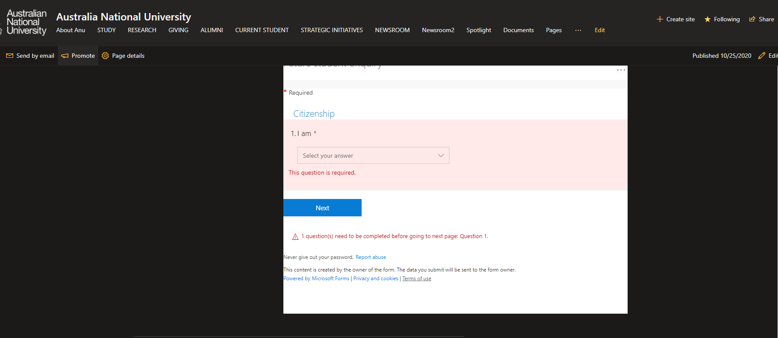

Figure: validation check of form

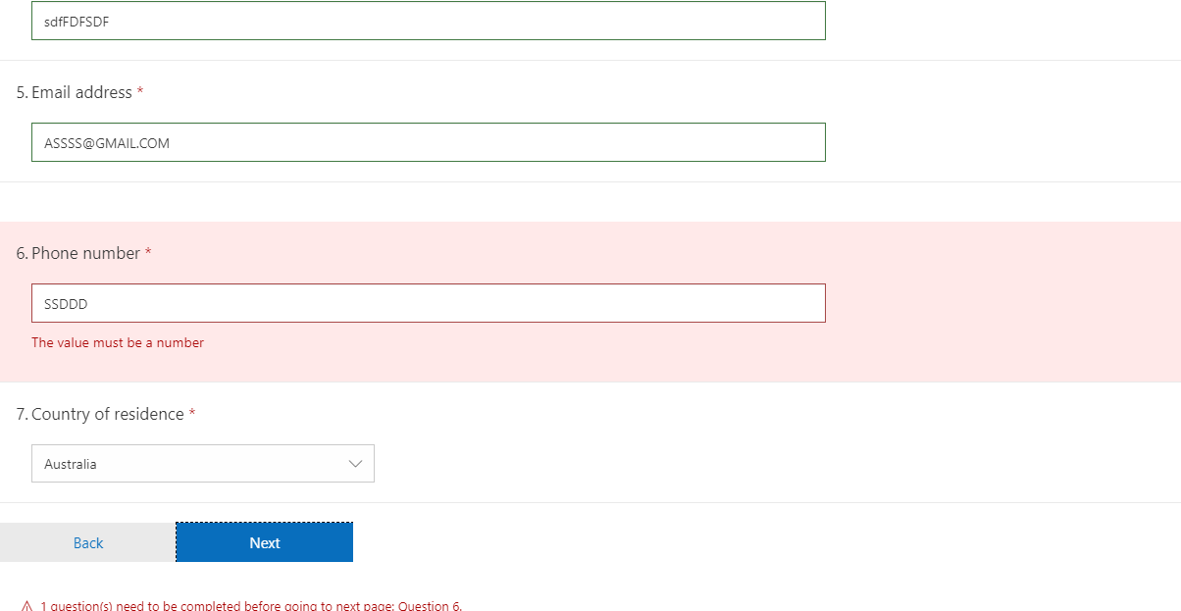

Figure: validation if wrong number is given in phone

|  |  |  |  |  |  |
| --- | --- | --- | --- | --- | --- |
| No | Title | Test steps | Expected result | Actual result | Action |
| 1.2 | Validation check of sharepoint | Leave blank space in sign in form | Should not allow to sign in | Same as expected | pass |

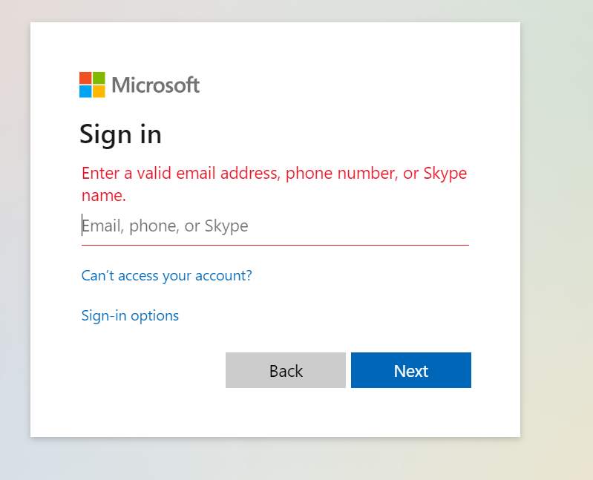

Figure: validation of SharePoint sign in form

**2 Integration test.**

|  |  |  |  |  |  |
| --- | --- | --- | --- | --- | --- |
| No | Title | Test steps | Expected result | Actual result | Action |
| 1.1 | While submitting information in enquiry form notification | Submit all information required in enquiry form | Thank you massage will be shown | Result as expected | pass |

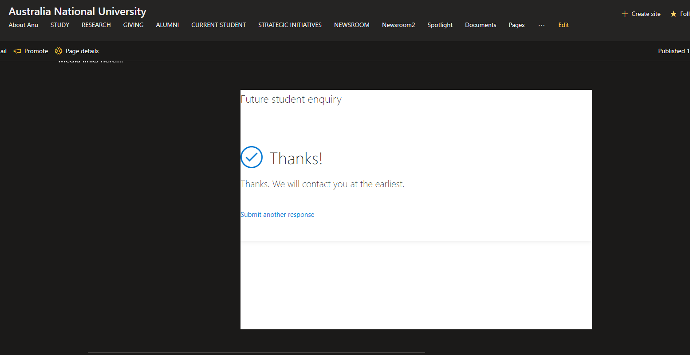

Figure: thankyou massage feedback from enquiry form

**3. Functional test.**

|  |  |  |  |  |  |
| --- | --- | --- | --- | --- | --- |
| No | Title | Test steps | Expected result | Actual result | Action |
| 1.1 | Registration | Enter data to alumni registration box | Data will enter in registration box | Alumni will be able register successfully | same |

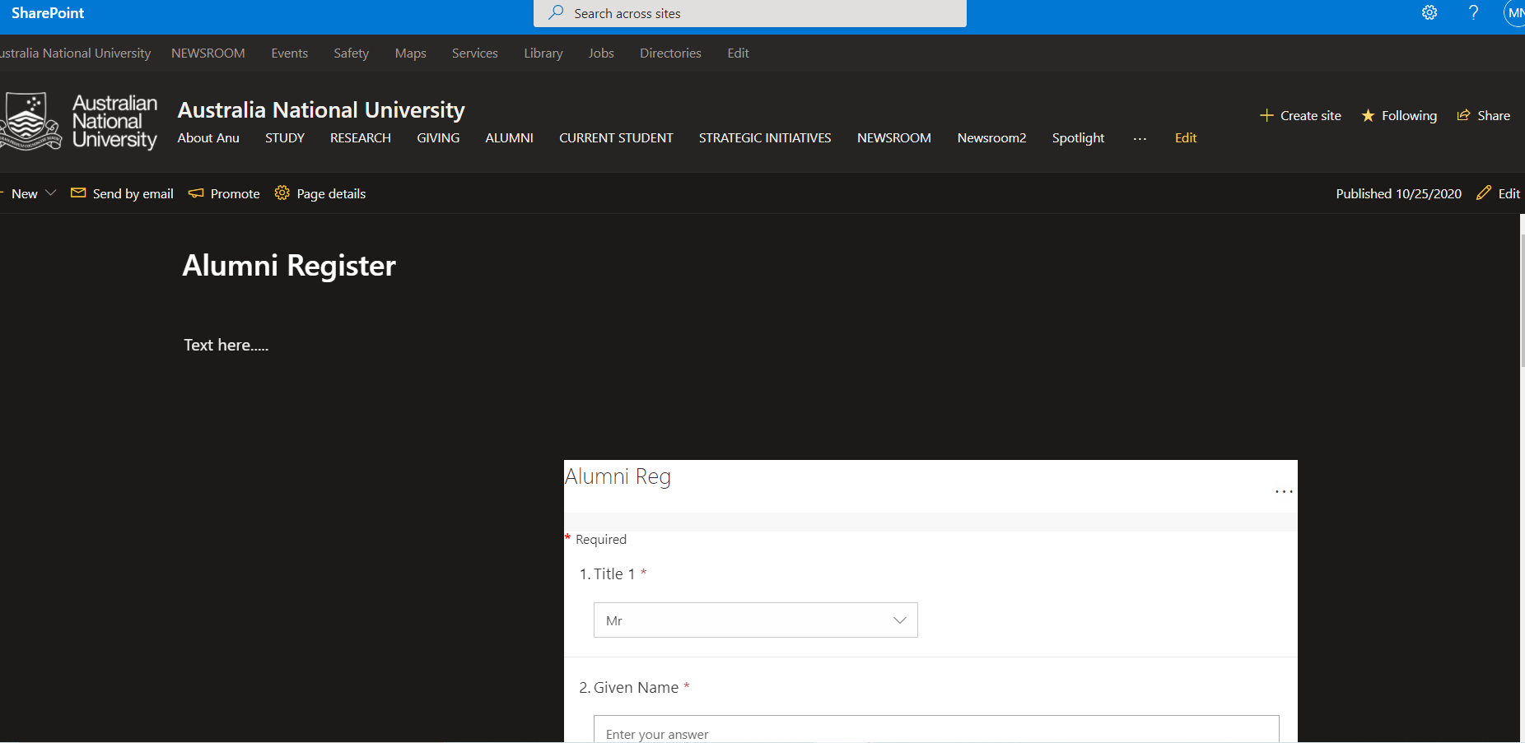

Figure: data input in alumni registration



Figure: data input in excel sheet for alumni registration

|  |  |  |  |  |  |
| --- | --- | --- | --- | --- | --- |
| No | Title | Test steps | Expected result | Actual result | Action |
| 1.2 | Data entry in citizenship box of enquiry form | Enter data to citizenship field | Data will enter in citizenship field | Data will enter in this box successfully | pass |

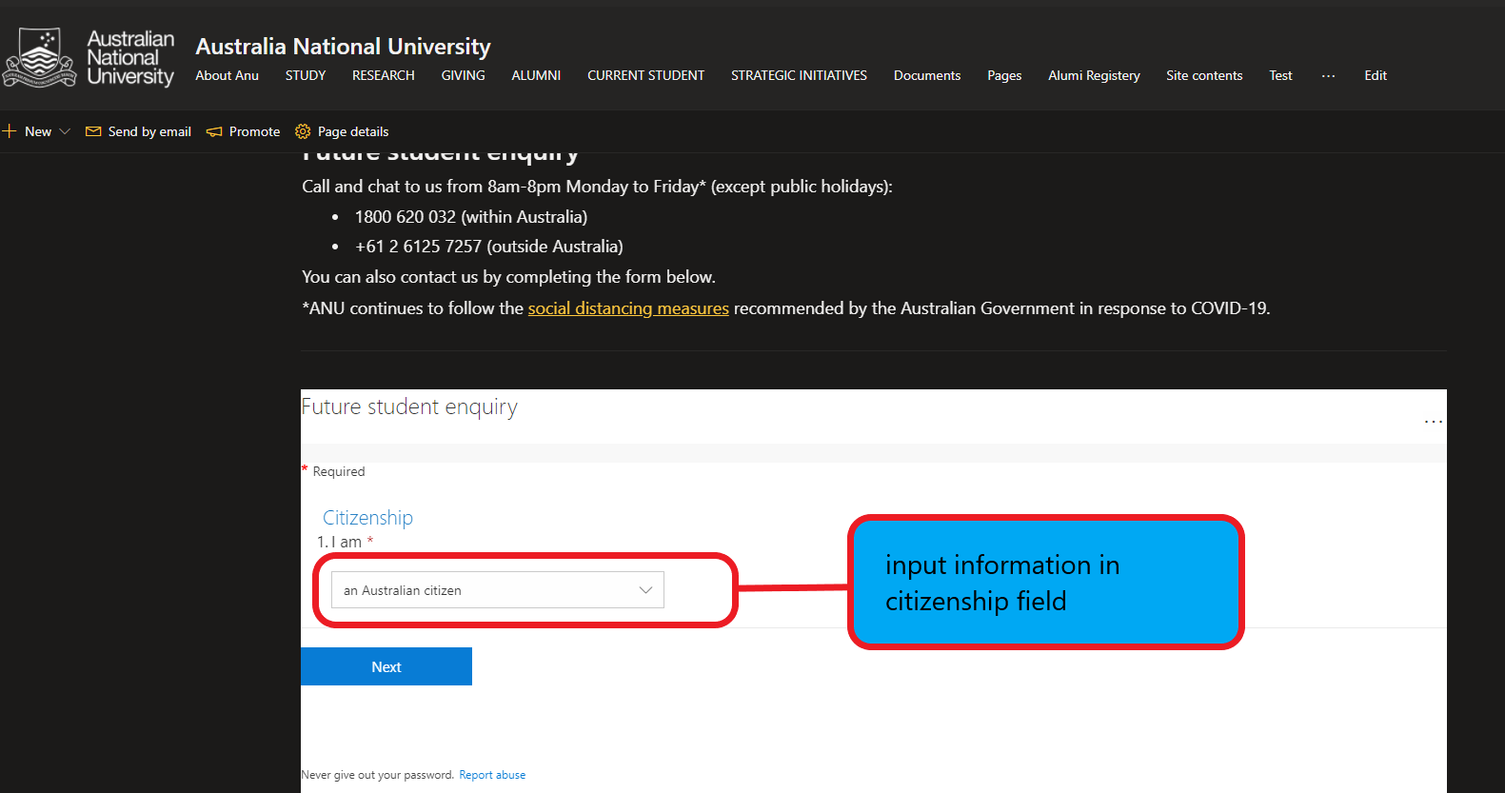

Figure: data input in citizenship field

|  |  |  |  |  |  |
| --- | --- | --- | --- | --- | --- |
| No | Title | Test steps | Expected result | Actual result | Action |
| 1.3 | Selecting options in your contact details | Select options in your contact details | Should be able to select options in your contact details | As expected | pass |

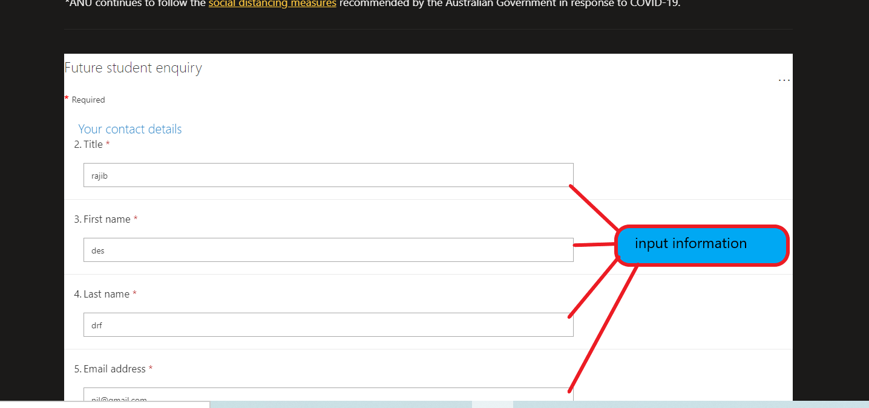

|  |  |  |  |  |  |
| --- | --- | --- | --- | --- | --- |
| No | Title | Test steps | Expected result | Actual result | Action |
| 1.4 | Selecting options in study option | Select options in study option | Should be able to select options in study option | As expected | pass |

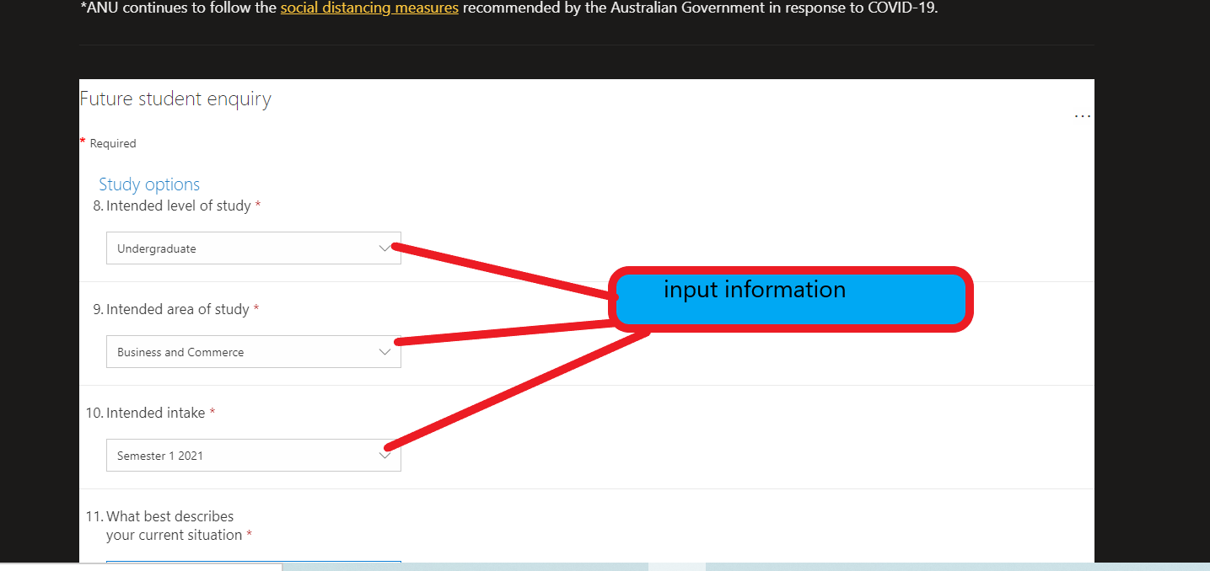

Figure: data input in study option field

|  |  |  |  |  |  |
| --- | --- | --- | --- | --- | --- |
| No | Title | Test steps | Expected result | Actual result | Action |
| 1.5 | Submitting any queries in ask us a question box | Submit a question in ask us a question box | Should be able to submit a question | A question will successfully enter in ask a question box | pass |

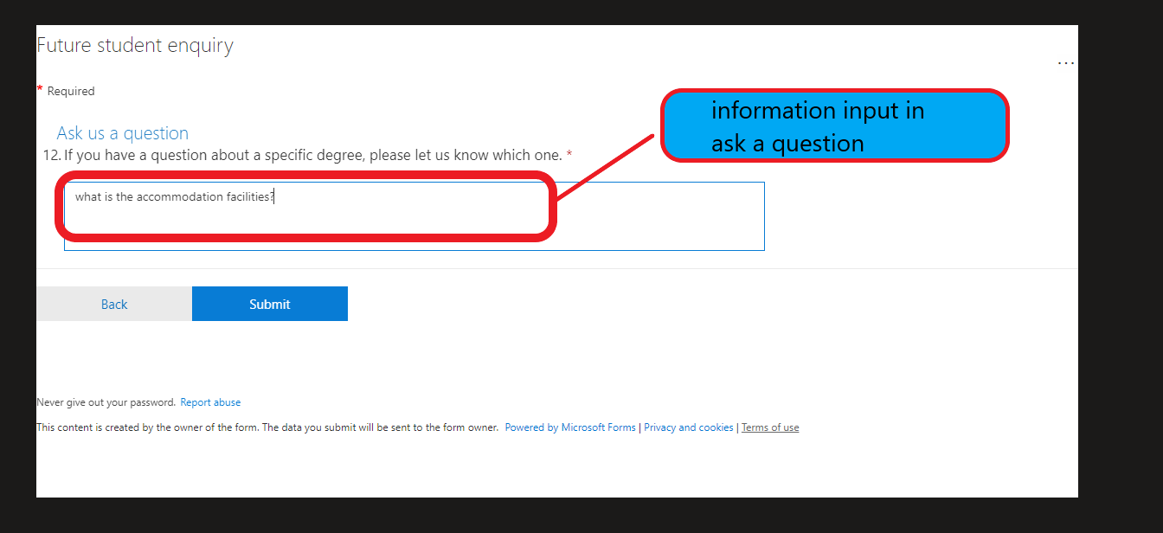

Figure: data input in massage box.



Figure: all the data inserted in future student enquiry form.

**4. Usability test.**

|  |  |  |  |  |  |
| --- | --- | --- | --- | --- | --- |
| No | Title | Test steps | Expected result | Actual result | Action |
| 1.1 | Easy to understand navigation bar | To check if the color fonts and size are user friendly | Navigation bar will work properly | Result as expected | pass |

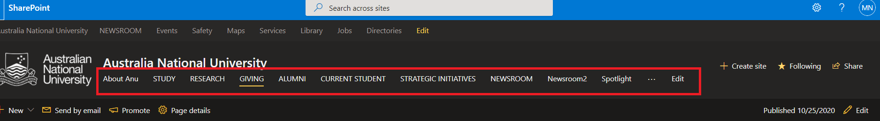

Figure: user-friendly navigation bar

|  |  |  |  |  |  |
| --- | --- | --- | --- | --- | --- |
| No | Title | Test steps | Expected result | Actual result | Action |
| 1.1 | Browser compatibility | View in different browser | Should Run in different browser   1. Google chrome 2. Mozilla Firefox 3. Microsoft edge | Result as expected | pass |

**5. Browser compatibility:**

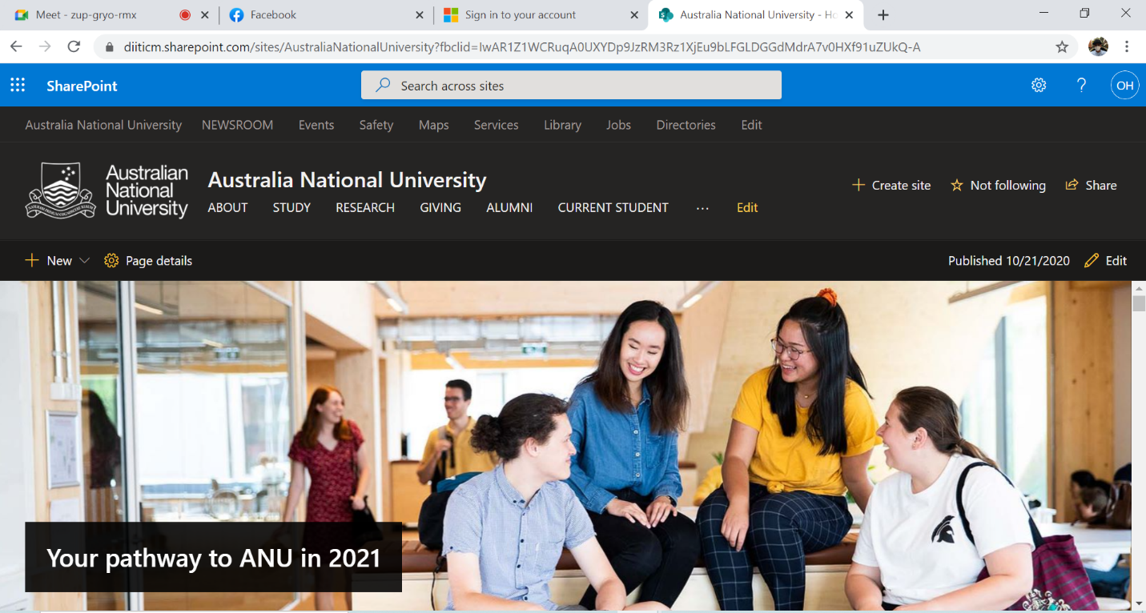

Figure: run in google chrome

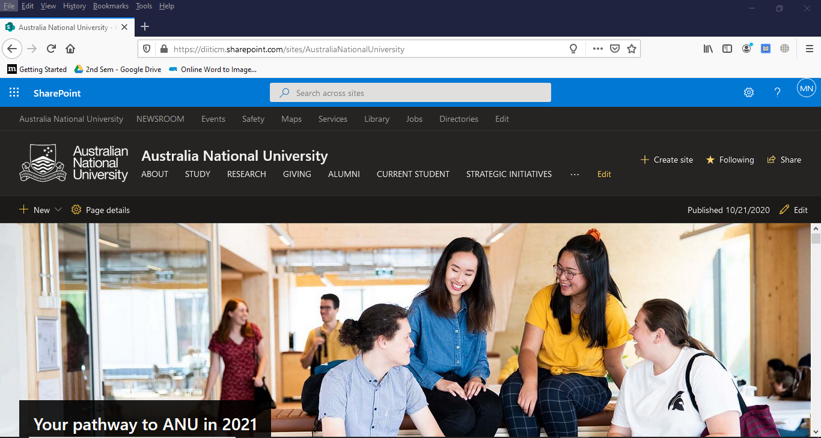

Figure: run in Mozilla Firefox

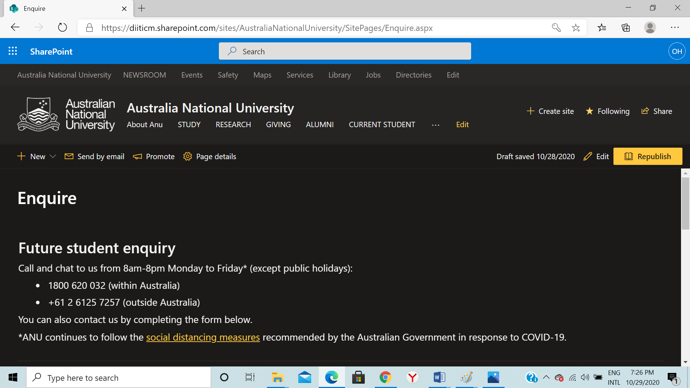

Figure: run in Microsoft edge.

**6. Responsiveness test:**

|  |  |  |  |  |  |
| --- | --- | --- | --- | --- | --- |
| No | Title | Test steps | Expected result | Actual result | Action |
| 1.1 | Responsiveness in different device. | View in different device | View in different device   1. Mobile 2. Tab 3. Desktop | Result as expected | pass |

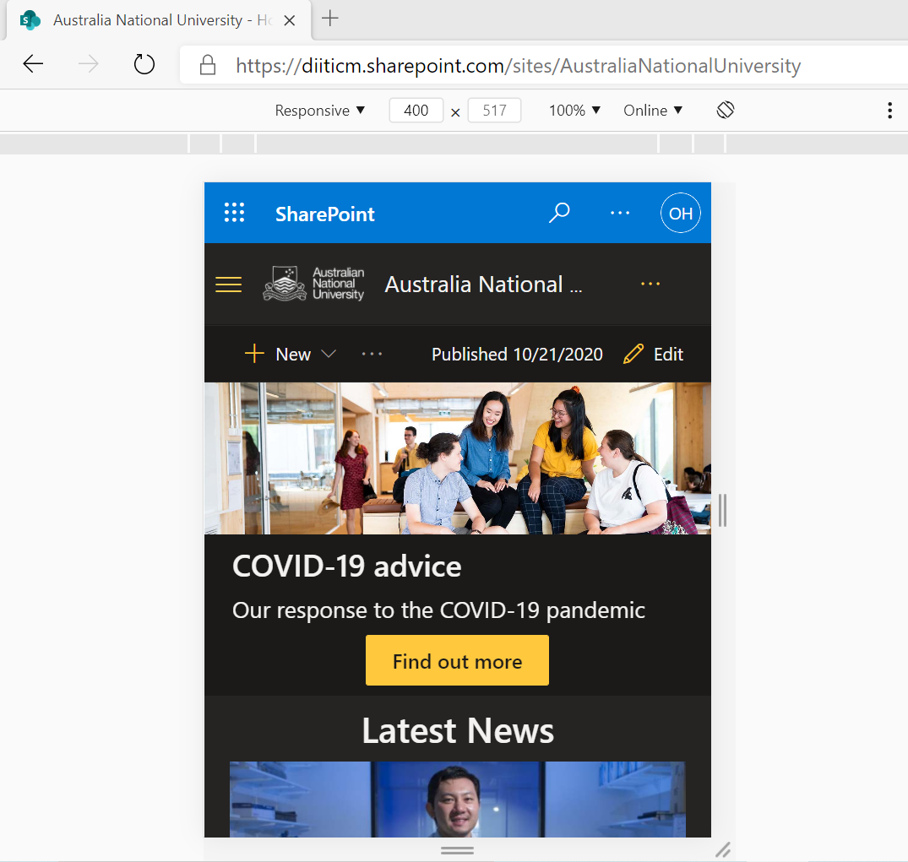

Figure: view in mobile format

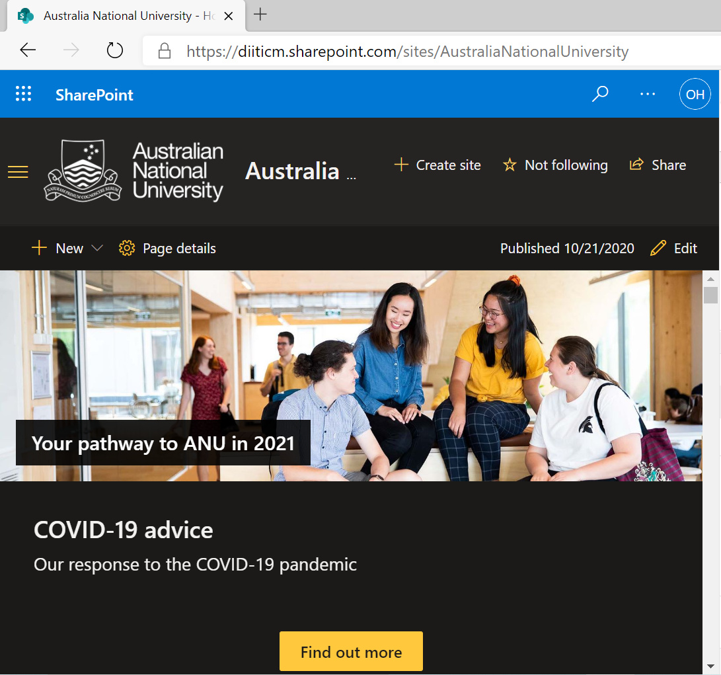

Figure: view in tab mode.

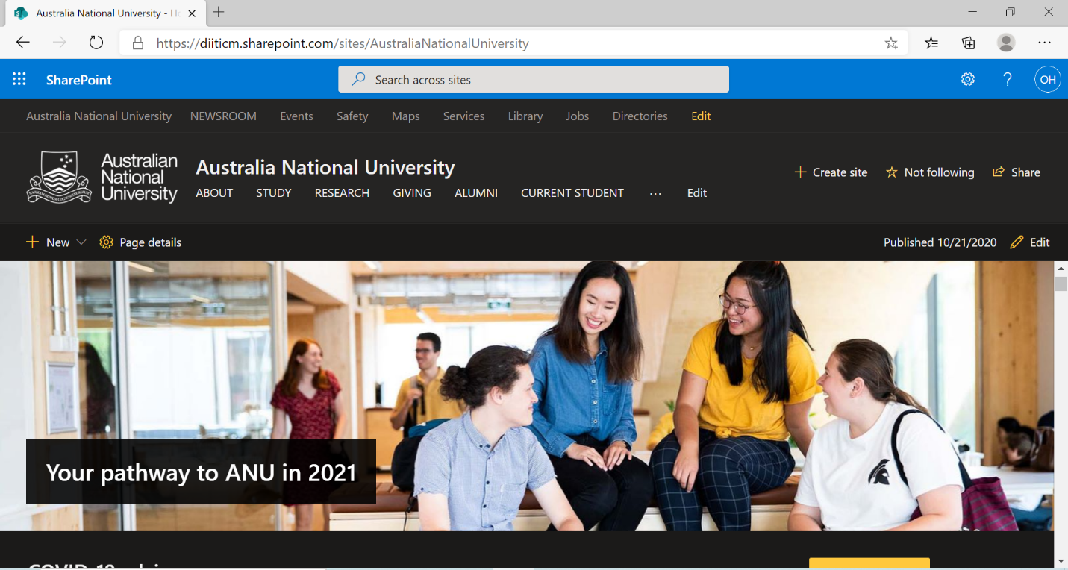

Figure: view in desktop mode.

**7. Security test**

|  |  |  |  |  |  |
| --- | --- | --- | --- | --- | --- |
| No | Title | Test steps | Expected result | Actual result | action |
| 1.1 | Process of authentication | Complete sign up by email | Should be able to sign in | As expected | pass |

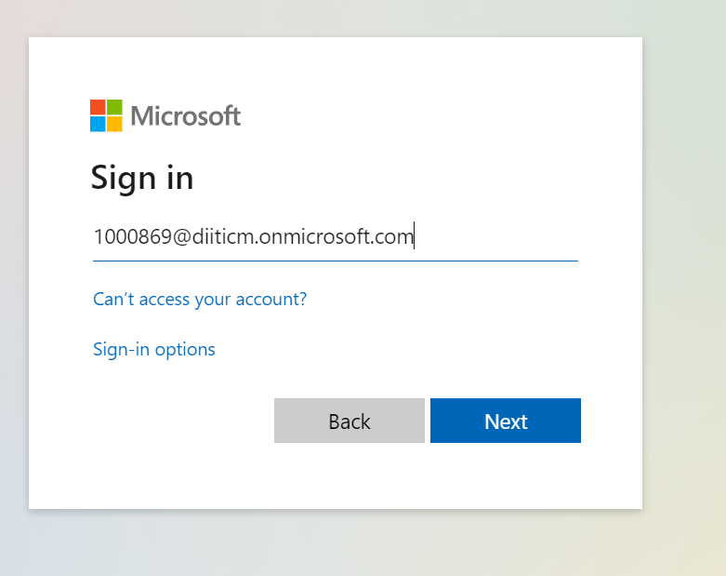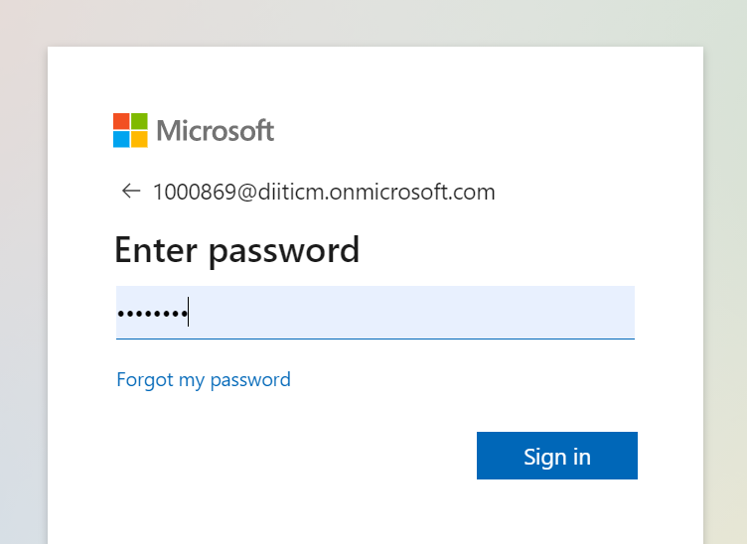

Figure: sign in SharePoint

|  |  |  |  |  |  |
| --- | --- | --- | --- | --- | --- |
| No | Title | Test steps | Expected result | Actual result | action |
| 1.2 | URL checking | Test url link in  https://www.site24x7.com/link-checker.html | Should show information if the link is ok. | As expected | pass |

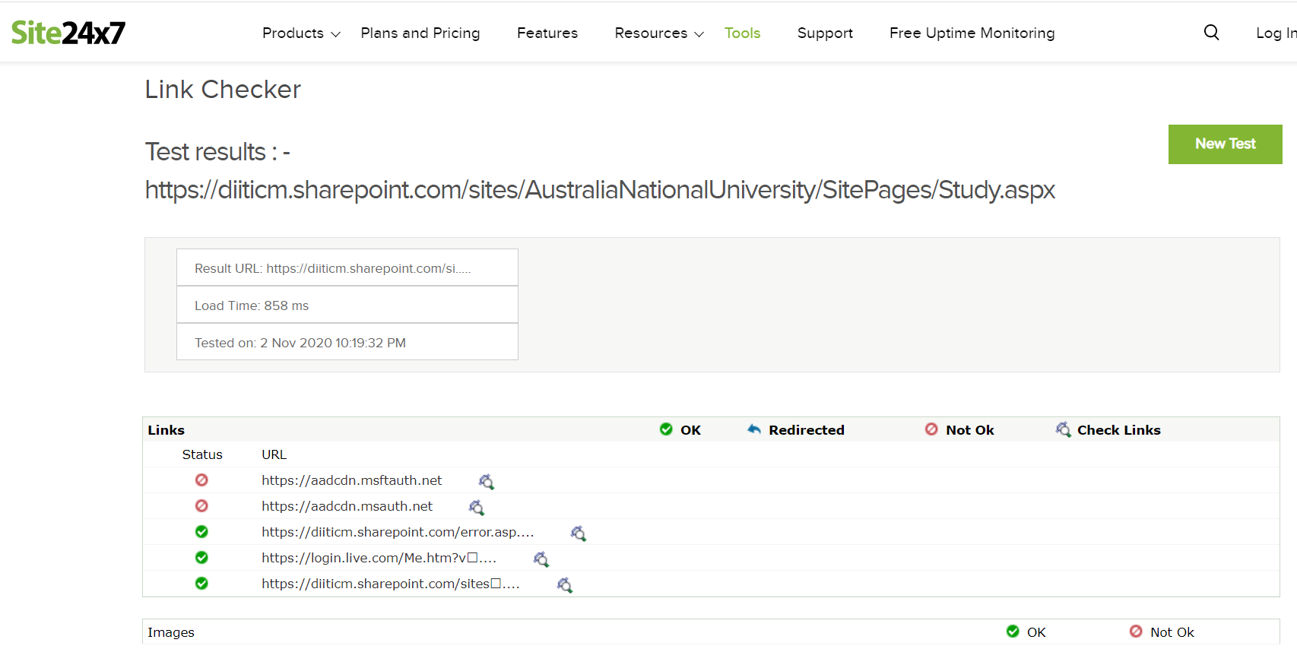

Figure: URL checking